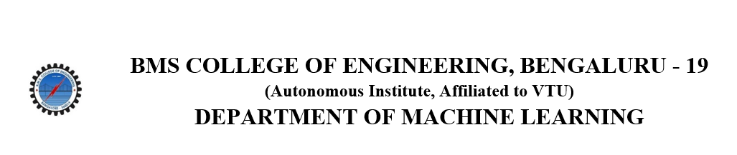
ACTIVITY REPORT
On
CareerCraft
- Name of the Club: BMSCE ACM STUDENT CHAPTER
- Name of the Activity: CareerCraft
- Objectives: The BMSCE ACM Student Chapter organized a workshop on
“Interview preparation”. This workshop aimed to give insights about interview preparation and internship opportunities
Date, Time Venue of the Activity:
Resource Person | Madhura Kawadiwale
TOPIC | Interview preparation, networking and internships
DATE/DAY | Tuesday, 5th March,2024
VENUE | Online
- Name and details of collaborating agency (if it is collaborative/joint activity): N.A
- Brief summary of the Programme: The workshop on interview preparation, networking, personal branding, and finding the right internship opportunity was meticulously curated by Ms. Madhura Kawadiwale, an esteemed interview preparation coach and soft-skills trainer, held from 6:00 p.m. to 7:30 p.m. With a wealth of experience in talent development, Ms. Madhura delved into comprehensive strategies tailored to elevate participants' career prospects. The session commenced with a deep dive into interview preparation, encompassing techniques to articulate strengths, handle behavioral questions, and demonstrate alignment with organizational values. Participants gained invaluable insights into crafting compelling resumes, optimizing LinkedIn profiles for professional networking, and leveraging social media platforms to enhance personal branding.
Throughout the workshop, Ms. Madhura seamlessly integrated practical exercises and role-playing scenarios, enabling participants to refine their communication skills, build confidence, and project a strong professional image. Discussions on effective networking strategies, including informational interviews and leveraging alumni networks, empowered participants to expand their professional connections and access hidden job markets. Furthermore, Ms. Madhura provided guidance on cultivating a distinctive personal brand, emphasizing authenticity, consistency, and storytelling to resonate with potential employers and stakeholders.
As the session concluded, Ms. Madhura underscored the importance of continuous learning and self-improvement in navigating today's dynamic job market. Participants left the workshop equipped with actionable strategies, renewed confidence, and a clear roadmap to pursue internship opportunities aligned with their career aspirations. The event's success was attributed to Ms. Madhura's expertise, engaging delivery style, and the collaborative efforts of the organizing team, ensuring a transformative learning experience for all attendees.
- Outcomes: The workshop provided invaluable insights into interview preparation, networking, and personal branding. Participants gained practical strategies and renewed confidence to navigate the job market effectively. Ms. Madhura's expertise and engaging teaching style ensured a transformative learning experience for all attendees.
- Number of participants:
Number of Faculty | Number of  Non-Teaching Staff | Number of  External Participants | Number of Students
0 | 0 | 54 | 54

- Two or three relevant Photographs of the activity: (Geo-tagged photos are preferable)
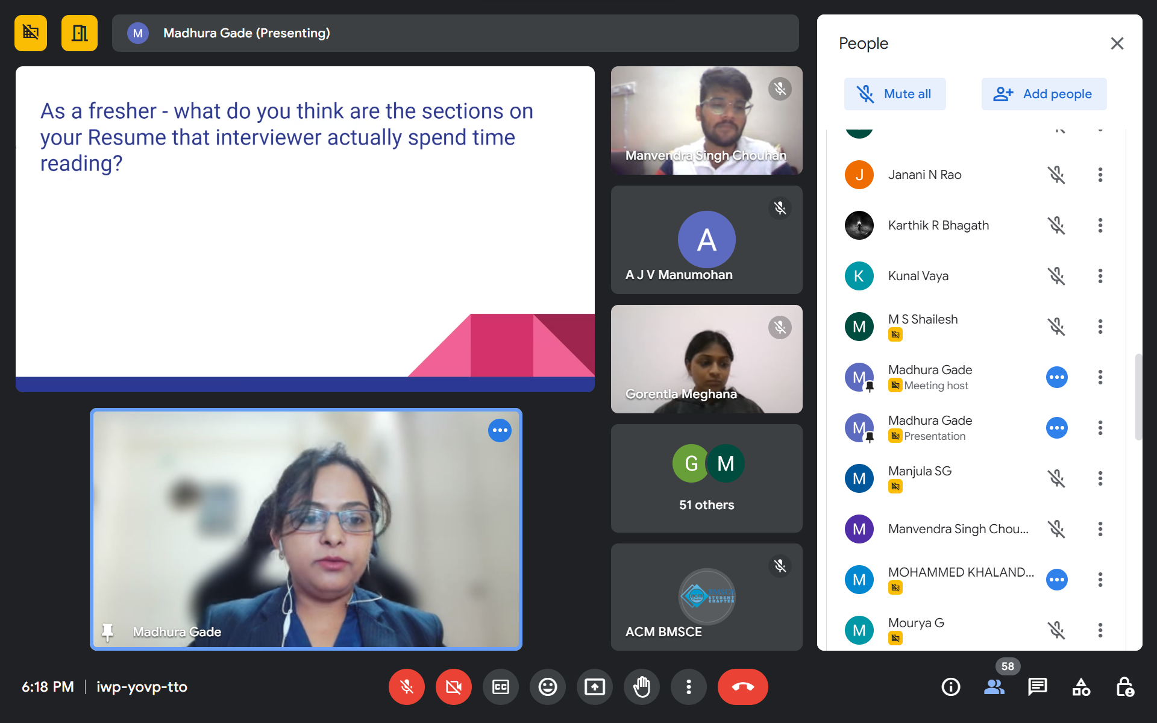

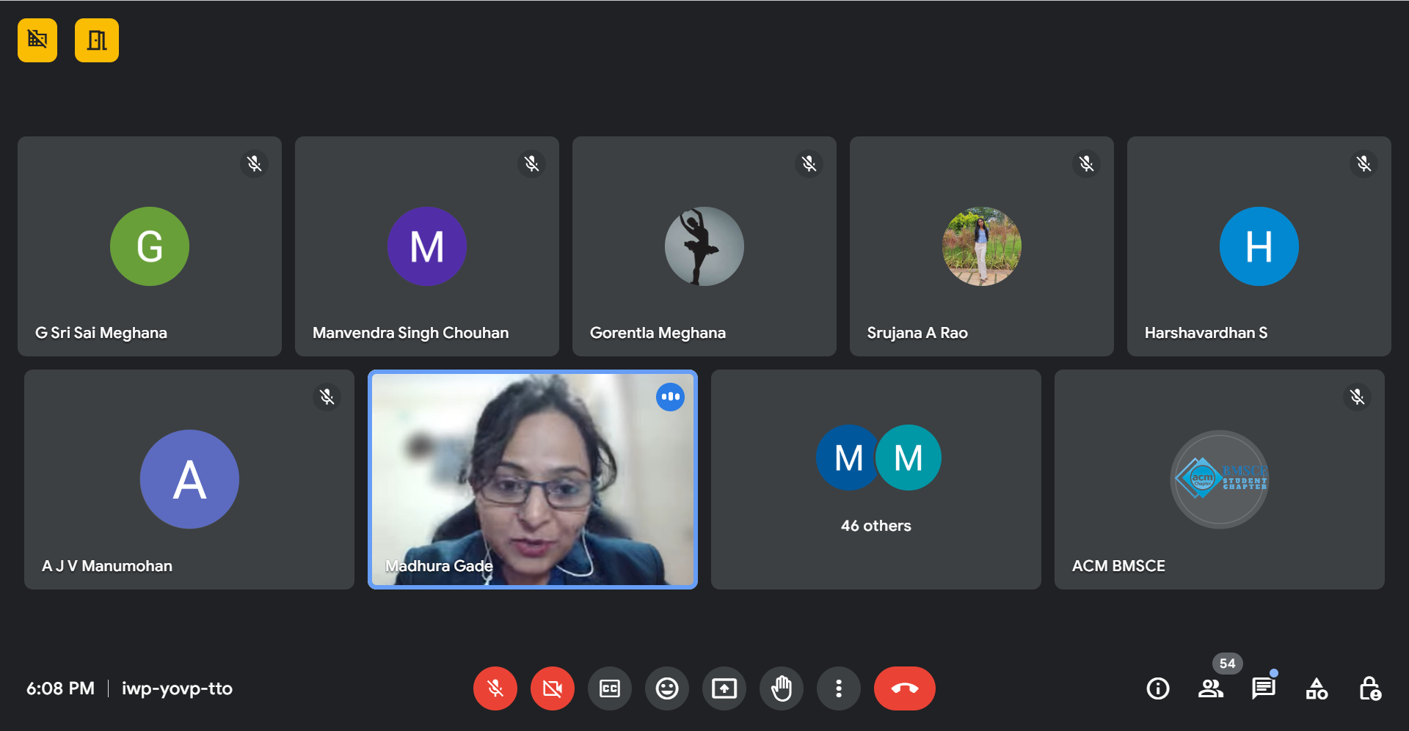
Supporting Documents
a) Attendance sheet
b) Circulars/Brochures
c) Certificates

